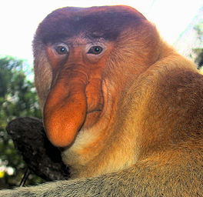
Proboscis monkey
Information
The proboscis monkey has a light orange fur with gray limbs and a white tail. The crown is orange, while the rest of the head paler colored. The face is beige, blue in young animals. The belly is the long digestive tract very thick. The adult male has a large, hanging down nose, females have a small blunt nose, and young animals turned up.
Funny fact
The Malaysian people call this animal the Orang Belanda either "Man resembles Dutch," which first sailors and missionaries meant that Borneo had put ashore. They had as much of a long nose and a belly as the proboscis monkey.
Empire: Animalia (animals)
Tribe: Chordata (chordates)
Class: Mammalia (mammals)
Order: Primates (Primates)
Family: Cercopithecidae (monkeys of the Ancient World)
Gender: Nasal

